Activity calculation:

The activity concentration of individual nuclides in the soil samples were calculated using the following equation:

Where:

A is the activity concentration of a certain radioactive nuclide in the decay series.
N_{net} is the net peak area count subtract background of the sample.
ε is the absolute efficiency of the detector.
I_{(γ)} is the emission probability of a specific energy photo peak.
t is time for collecting the spectrum of the sample.
m is the weight of the sample.

For example:

The activity concentration of 137Cs (662.94keV) in a soil sample was determined:
The net count under that peak = 409± 90 counts/2days.
The net count in the background under that peak =271±92 counts/2days.
ε= 0.097% at energy 662.94keV.
I_{(γ)} = 0.8510 the emission probability of the gamma ray line 662.94keV.
t =172800s.
m = 0.109579±0.000001kg.
Substituting these values in equation (1) the activity will be:

This calculation was done by assuming that the all correction factors are equal to unity.

Determination of critical level and minimum detectable activity of the counting
system:

The critical levels for the counting system were found using the following equation:

where, , is the standard deviation of Gaussian distribution for the number of counts in the
background. This is a decision limit to ensure that the false positive and the probability will be no
larger than 5%.
In addition, MDA was evaluated for the background spectrum and soils using:

is the background count under specific photo peak energy in background and soils.
Such as, calculation of and MDA 226Ra (185.94keV) were performed.
The number of counts recorded under that peak was 1337±385 counts.
Therefore, and MDA are given by:

THEORETICAL DETERMINATION OF THE EFFICIENCY OF A NaI DETECTOR

The intrinsic total efficiency is defined as the ratio of the total number of events which are detected to the total number of γ-ray photons incident on the detector. It is determined by the total attenuation coefficient. The plot below shows the total interaction probability, the probability of any interaction occurring, for γ-rays passing through 7.6, 10.0, and 15.2 cm of NaI(Tl). At 662 keV, for example, about 87% of the incident γ - rays will interact when passing through 7.6 cm of NaI(Tl).

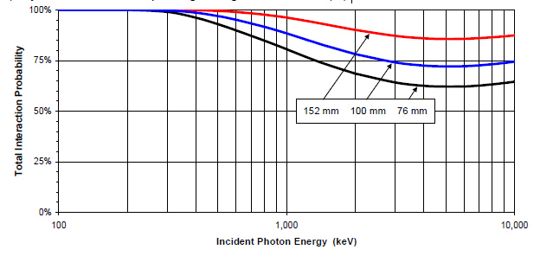

The fraction of the photons absorbed by the detector f is calculated¹ by subtracting the fraction that pass through the detector from 1:

(1) It is assumed here that all photons are traversing the same amount of detector material. A correct procedure takes into account the different paths and their path lengths and sums or integrates to find the total fraction
.

The photofraction R is defined as the ratio of the number of events which deposit their full energy in the detector, forming the photopeak, to the total number of events which are detected. For a NaI(Tl) detector, photoelectric events predominate for photons of 100 keV or less energy. Above 100 keV, Compton events become appreciable and, above 2 MeV, pair production events become appreciable. For these higher energy cases, it is necessary to know the fraction of events in the photopeak or the peak-to-total ratio R. There is no easy way to calculate it because it depends on different factor, such as the diameter of the detector and the source distance. In a 7.6x7.6 cm NaI(Tl) detector the photopeak efficiency is closer to 50%, so most of the photopeak events are not due to photoelectric interactions.

Peak Presets: Lower Level Discriminator

The lower level discriminator, abbreviated LLD, is the energy below which we are not interested in any detector response. The LLD will always be below our lowest energy and efficiency calibration point, and will always be greater than zero keV. In routine analyses the lowest calibration point is usually 59 keV. Below that point on the energy response curve, we are not calibrated. Thus extending the recorded range of counts down to about 50 keV allows a good view of gamma rays just below the 59 keV region. The reason that we want to cut out any information from the detector below this energy is that as energy decreases the background generally increases. The background radiation detected leads to two types of dead time; detector dead time and analog to digital conversion (ADC) dead time. We cannot do anything about detector dead time because the gamma rays interact directly with the crystal. We can do some thing about ADC dead time. We minimize it by setting the lower level discriminator just be low the lowest calibration point. The lowest calibration point is usually at 59 keV (from 241Am), so a good energy to set the LLD at is about 50 keV. Fortunately the detector dead time is much less than the ADC dead time.

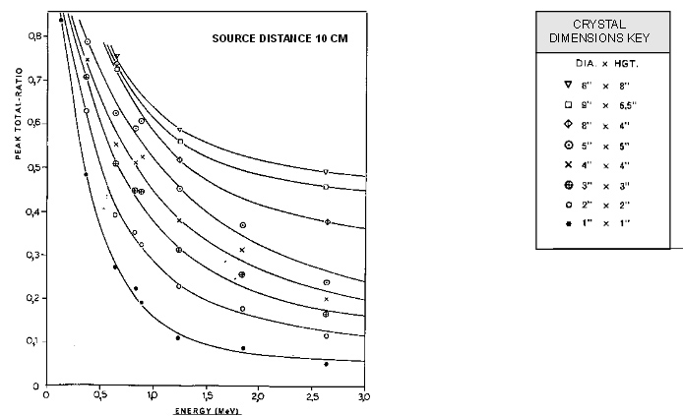

The intrinsic photopeak efficiency is the ratio of the number of full energy events to the total number of γ-ray photons incident on the detector. It is the product of the intrinsic total efficiency and the photofraction For Cs-137 and a 7.6x7.6 cm NaI(Tl), it is (50%)(87%)=43%.

The absolute total efficiency ε (for the source-detector geometry used) is defined as the ratio of the total number of events which are detected to the total number of γ-ray photons emitted by the radioactive source. It is the product of intrinsic total efficiency and a geometric factor GF, which yields the fraction of the emitted γ-rays which are incident on the detector. Unless the detector completely surrounds the source, the geometrical factor is less than 1. In effect consider the geometry sketched below. A source is located a distance R from a detector with area A facing the source. The γ-rays are emitted isotropically, i.e. with equal probability in all directions, with solid angle 4π steradians. Seen from the source, the detector subtends a solid angle Ω, defined by the area of the detector, which determines the geometric factor. At a large distance, the fractional solid angle is just the area A divided by the area of a sphere with radius R eual to the source to detector distance, and this is the fraction of γ-rays incident on the detector¹. For a 7.6 cm dia detector at 4 cm, the geometric factor is 0.23, as calculated below.

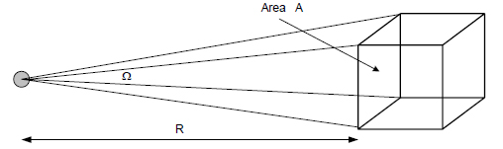

(1) Note that this is an approximation. The numerator should be the area of the spherical section obtained by integrating the area element instead of the area of the flat disc.

Actually, the simple formulas only holds if the separation between the source and detector is large. If we consider the limit of small separation, the detector subtends half the solid angle, and this does not change even if the source is moved slightly away from the detector. For intermediate values, analytical approximations have been computed for a variety of different geometries.

Now you should consider the fraction L of the photons transmitted by the intervening materials that reach the detector surface. There are losses due to absorption by material in the path of the photon. Air, detector housing materials and light reflectors around the detector are possible absorbers.
To calculate, let us consider the effects of 4 cm of air and 0.020 inches of the thickness of aluminum housing.

In this case the attenuation by intervening materials is only a 1 % effect but if the photon energy were lower, the losses would be greater, e.g., for 59.5 keV for Am-241:

Note that the absolute efficiency is defined in terms of the number of γ-rays emitted by the source,
rather than by the number of radioactive decays. Not every decay is accompanied by the emission of a γ- ray. For example, in 137Cs the 662 keV γ-ray is emitted in 85% of the decays.

The fractional abundance for decay to the 661 keV excited state of the progeny is 94.4%. However, 9.3 % of the 94.4% of the gamma rays that are in the excited state, decay to the barium-137 ground state by internal conversion instead of by gamma ray emission.Thus the final fractional abundance for the gamma ray is 94.4 % -9.3 % or 85.1%.

Gamma Ray at differente energies are detected with differnce efficiencies. This means that a large number of counts at one energy and a smaller number at another energy does not necessarily mean that the source at the first energy has a larger activity. So we need to perform an energy-dependent efficiency correction.

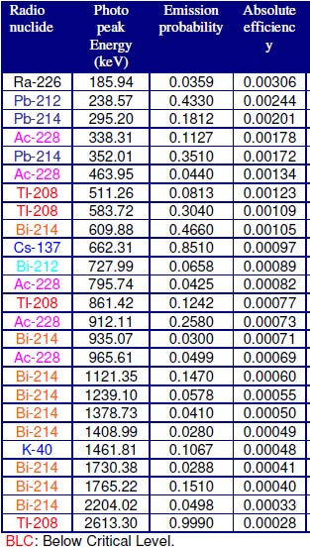

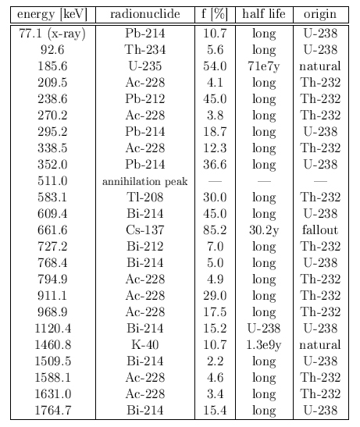
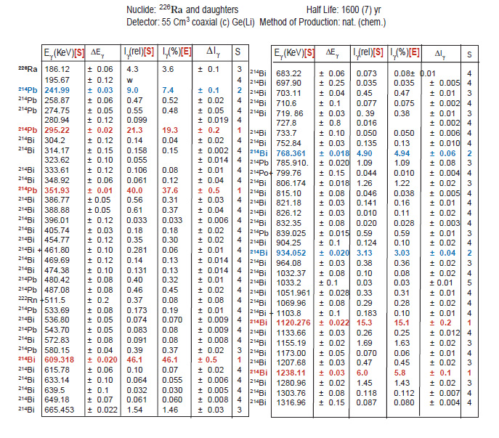

Live Time versus Dead Time

What do the terms live, dead and clock time mean? A way of thinking of these times is from the following analogy. A standard NFL football game is comprised of 4 quarters of 15 minutes. Theoretically, the game should take only one hour. However as we know a football game usually lasts for 3-4 hours. Why? The 60-minutes are the “live” time of the game. That is the time during which active play is taking place. Any time the referee blows the whistle to stop play and before he whistles to restart play is “dead” time. That is, no action is occurring during that time period. If we add together the “live” time and the “dead” time we get the “clock” time, or the total amount of time to play the game, also called “real time”. Radiochemistry counting systems work the same way. The detection system can only record counts during “live” time. Whenever the instrument is processing a signal it cannot respond to events in the detector-this is dead time.
Some gamma ray instruments have meters that display the % dead time. Other instrument systems identify the dead time on the report for each sample counted. For environmental samples the level of radioactivity is generally very low and the commensurate dead time for these samples is also low. However, regardless of the % dead time recorded, it is the clock time that needs to be sued in the activity equation since it that time during which the counts are actually collected.
Efficiency calibration. Experimental determination of the total efficiency.

When a spectrum is measured, it is partially buried in a background. This is why it is required to subtract the background from the net peak. The idea of how this is done in this experiment is shown in figure. First of all, it is necessary to decide which channels actually belong to the peak. Suppose these are channels 5176 to 5190, that is n = 15 channels. The content of these channels (which is the sum of all counts in channel 5176 to 5190) is N_{tot}. Then, with a constant distance d to the left and to the right preserved, the same amount of channels n used for summing up its count contents. Let the sum of counts within the n channels to the left of the peak be N_{BGL}, and the one to the right be N_{BGR}. The average of them is N_{BG} = (N_{BGL} + N_{BGR})/2. Consequently, the net number of counts in the peak Nnet can be obtained:

The latter result has been obtained assuming that both the peak and the background can be adequately represented by a Poisson distribution.

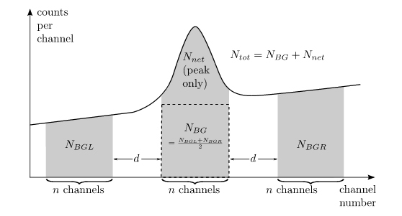

The activity of a radioactive source is usually given in Curies (abbreviated Ci). One Ci is defined to be 3.7 x10¹⁰ disintegrations per second (dps):
N_{A} can be calculated from the activity A by multiplying by the branching fraction BF for that mode of decay and the branching ratio BR for that photon energy and the counting time interval t. (Sometimes the total branching ratio B_{T}, which is the product of BF and BR, are given).

As an example, consider the 662 keV emission from Cs-137 where: BR = 0.944 BF = 0.9011, thus:

The total branching ratio is:

If the source calibration is not current, the source strength A must be corrected for the elapsed time by the equation:

A= the current activity
Ao = the activity when calibrated
t= time interval since the source strength was calibrated
τ= mean-life in the same units as the time interval (mean-life = half-life x 1.4427).
As an example consider a 1 μCi of a Cs 137 isotope which half-life is 30.07 years. If the source strength was calibrated 15 years ago, then t = 15 years,
τ = 30.07 years x 1.4427= 43.38 years and:

This shows that a Cs 137 source loses 29 % of its activity in 15 years!

Note: usually an error of 5% for A₀ was inscribed on the sample. The exp() term itself is assumed to have pratically no error at all. So:

Error of inizial activity:

As another example consider a 1 μCi of a C0-60 isotope which half-life is 5.27 years. If the source strength was calibrated 1.2 years ago, then:

τ = 5.27 years x 1.4427= 7.6 years and:

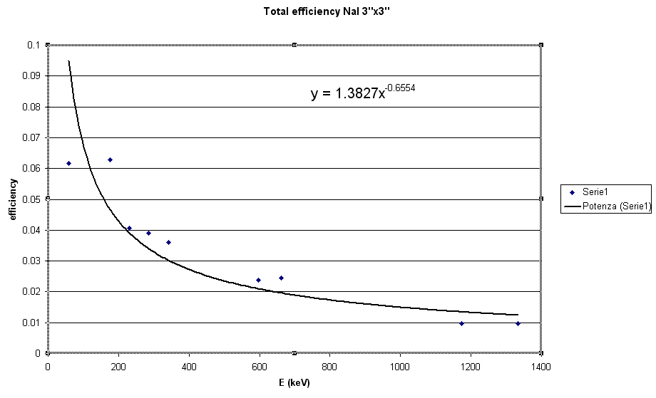

Efficiency Plots

The graph shown on this slide is an example of an efficiency plot for an HPGe detector with an aluminum cover. Note that as energy increases from about 50 to 130 keV that the
efficiency increases. This is because the gamma ray energy can better penetrate the aluminum shielding around the germanium crystal with increasing energy. However at~130 keV the efficiency begins to decrease because of the predominant interaction becoming Compton versus Photoelectric Effect.

Activity calculation:

The activity concentration of individual nuclides in the soil samples were calculated using the following equation:

Where:

A is the activity concentration of a certain radioactive nuclide in the decay series.
N_{net} is the net peak area count subtract background of the sample.
ε is the absolute efficiency of the detector.
I_{(γ)} is the emission probability of a specific energy photo peak.
t is time for collecting the spectrum of the sample.
m is the weight of the sample.

For example:

The activity concentration of 137Cs (662.94keV) in a soil sample was determined:
The net count under that peak = 409± 90 counts/2days.
The net count in the background under that peak =271±92 counts/2days.
ε= 0.097% at energy 662.94keV.
I_{(γ)} = 0.8510 the emission probability of the gamma ray line 662.94keV.
t =172800s.
m = 0.109579±0.000001kg.
Substituting these values in equation (1) the activity will be:

Note that this time, error propagation (according to Gauss) was necessary to employ:

The error of the efficiency was appropriately set to Δε = 0.001

